- FIND THE CENTER YOU CURRENTLY BOWL YOUR YOUTH LEAGUE IN
- Clicking on the bowling center name will take you to the on-line registration for your district
- Click on ‘Register’ of the tournament you are entering (Pepsi is Red, Handicap is Blue)
- Select a date to bowl (available dates are bold)

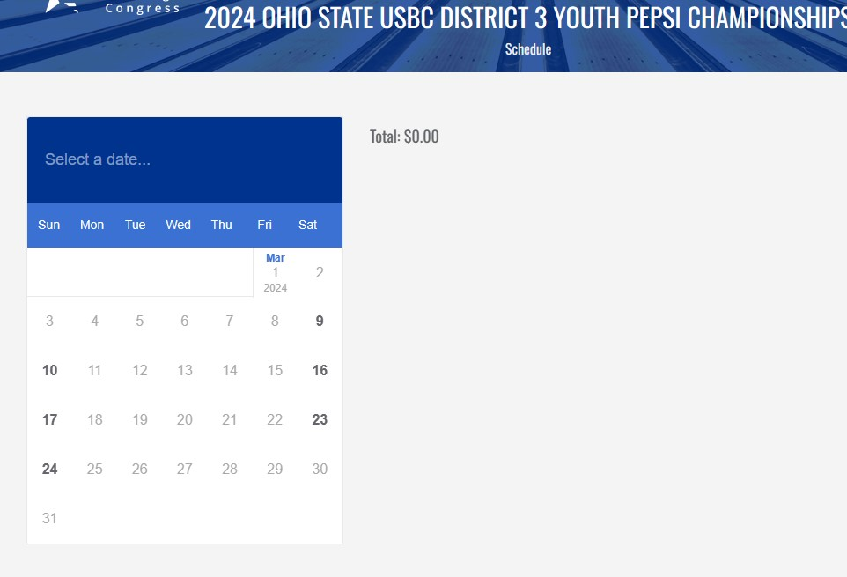

- Select a time to bowl by entering the number (quantity) of spots you want to buy (1 bowler, 2 bowlers, etc). THEN CLICK ‘ADD’

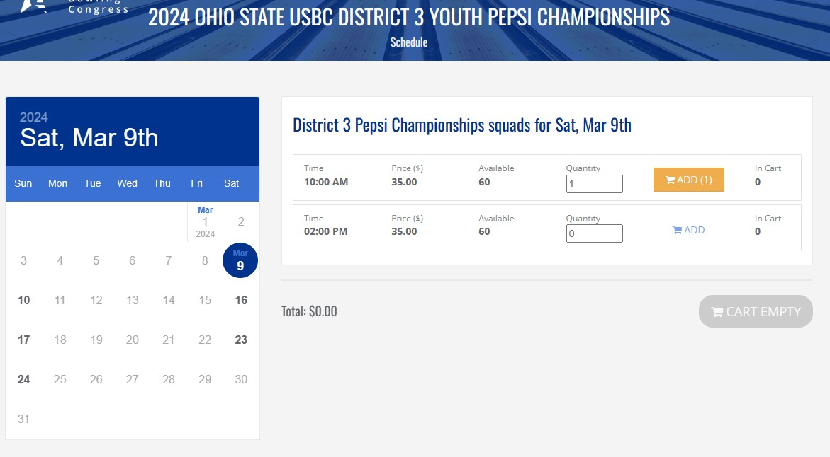

- By clicking ‘ADD’ you have put it in your cart and can now REVIEW SELECTION

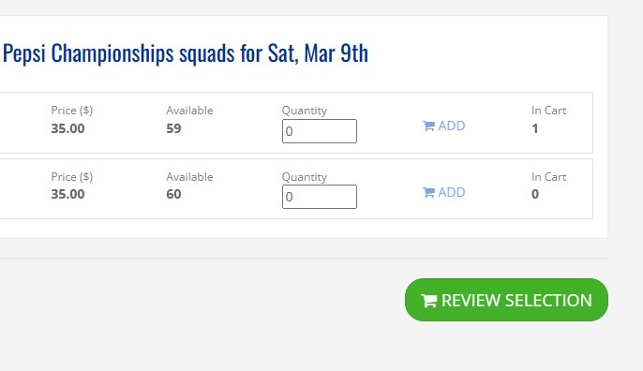

- In the Review screen you have the option to change your mind as well. You can ‘clear your cart’ or ‘return to the calendar’ to re-select or add another bowler. If you agree with the review screen, choose PAY FULL AMOUNT
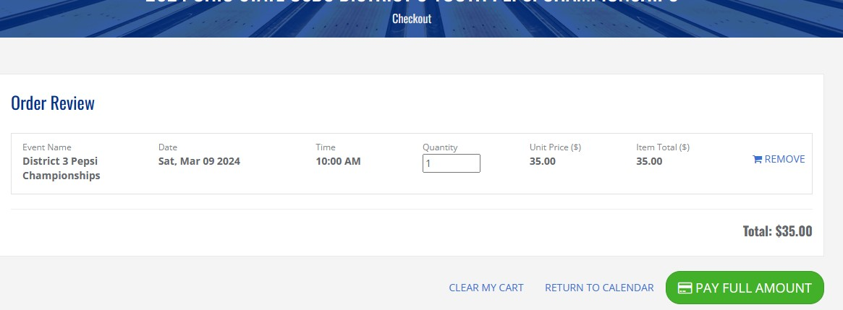

- Enter your email (that you used when registering for your community log in) and payment information
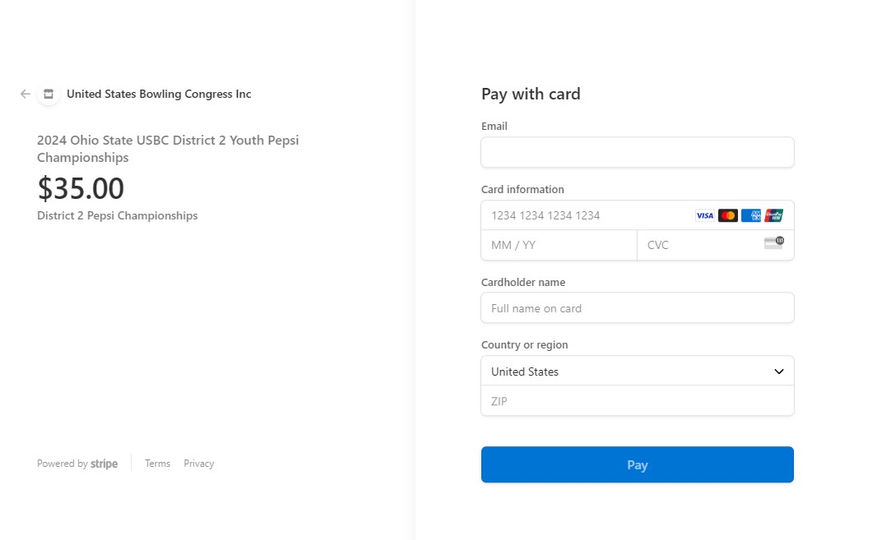
- You will receive your confirmation in your email and the program will take you back to the Event Page.

-NEXT-

- Click on Manage of the event you just registered for

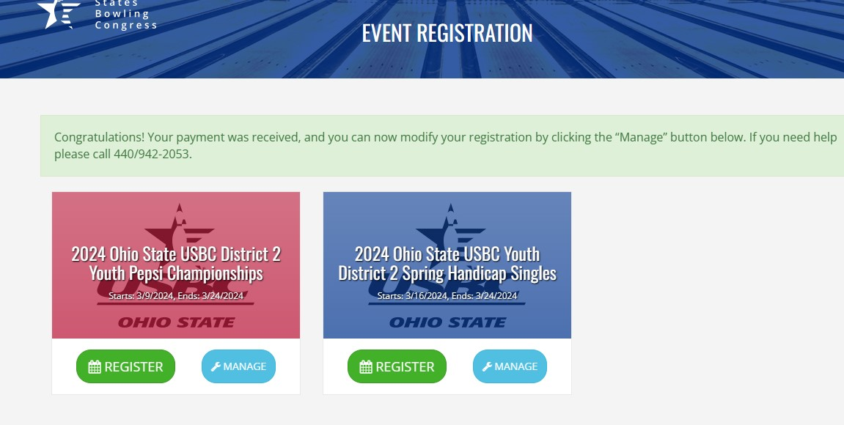

- Go to ‘ACTIONS’ and choose ‘MANAGE ROSTER’

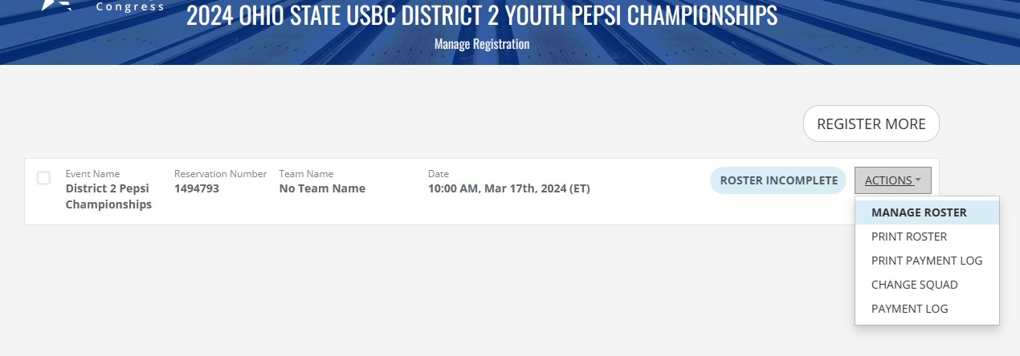

- ENTER YOUR (BOWLER’S) ‘MEMBER ID (###-###)’ AND CLICK ON THE PLUS (+) SIGN.

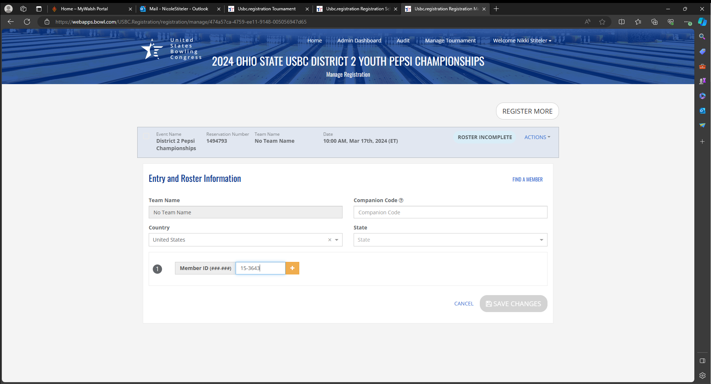

BOWLERS NAME WILL APPEAR BELOW THE BOX AND AT THE TOP, UNDER TEAM NAME

IF YOU ARE SIGNING UP FOR THE SPRING HANDICAP, ENTER THE BOWLER’S AVERAGE, REMEMBER TO SEND CURRENT STANDING SHEET WITH GAMES BOWLED THROUGH DECEMBER 16, 2023 TO YOUR DISTRICT DIRECTOR

Click ‘SAVE CHANGES’

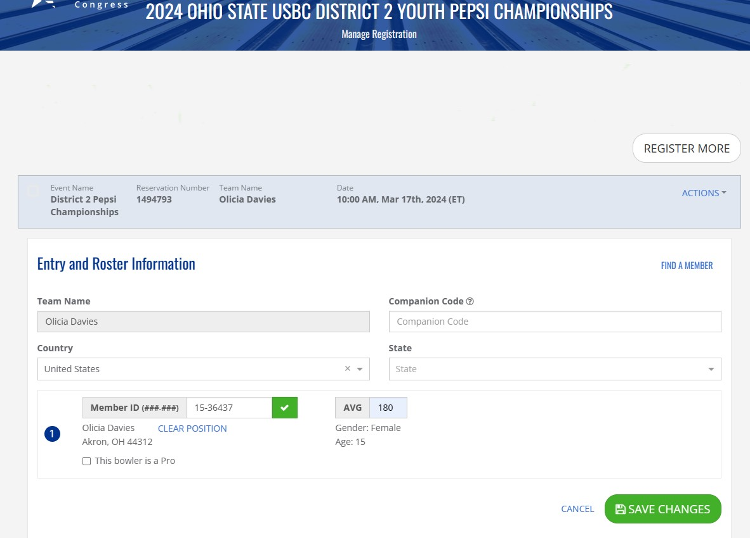

After clicking ‘Save Changes’ you will see ‘you’re all done’ at the top of the page

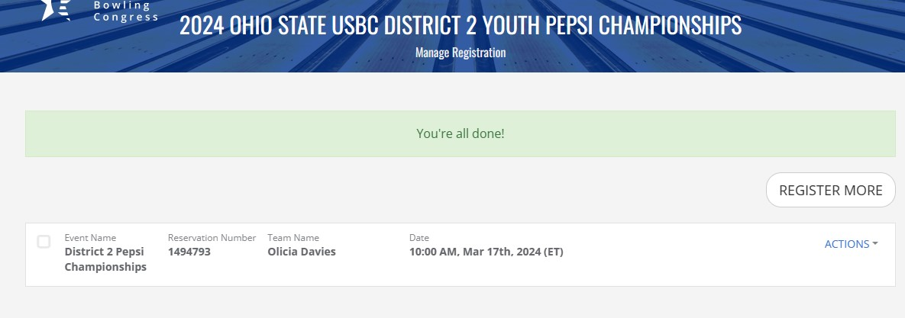

IF CHANGES NEED TO BE MADE TO YOUR REGISTRATION YOU CAN GO BACK INTO THE MANAGE BUTTON AT ANY TIME, UP TO THE DEADLINE DATE, TO MAKE THOSE CHANGES.

You can get to your registration by following the ‘view my registration’ link in your emailed confirmation as well. E-mail come from ‘USBC’

Nikki Stiteler,

Welcome to the 2024 Ohio State USBC District 2 Youth Pepsi Championships!
Your payment has been received and here are the details of your entries:
- Reservation Number 1494793: District 2 Pepsi Championships, 03/17/2024 @ 10:00 AM ET
​
View my Registration on USBC Event Registration to confirm the accuracy of your registration, manage your team rosters, print your confirmation or purchase additional events.
The following are the host centers for this tournament
Stonehedge
580 E Cuyahoga Falls Ave
Akron, OH 44310
330/928-2161
Should you have any questions, please contact your Tournament Manager:
Linda LeMay
lgwba@yahoo.com
440/942-2053

We look forward to seeing you!

This is an automated email notification and cannot receive replies.

Copyright © United States Bowling Congress
621 Six Flags Drive • Arlington, TX 76011
800.514.2695 • bowlinfo@bowl.com

