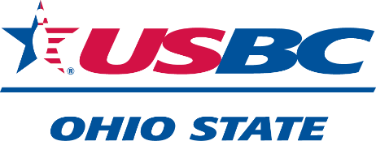
Ohio State USBC Convention Weekend
2025
Schedule of Events
Embassy Suites by Hilton Columbus Airport
2886 Airport Dr., Columbus, OH 43219

Friday 7:00-9:30 PM Delegate Welcome Party
May 16 BBW Exchange Mart

7:30-9:00 PM Delegate Registration

Saturday 8:00 AM Ohio Local Presidents Club Meeting
May 17
9:00 AM Ohio Association Leaders Club Meeting

10:00 AM Buckeye Bowling Writers Meeting

Saturday 11:30 AM-1:30 PM Related Clubs Luncheon
Awards Presentation

12:30-2:00 PM Delegate Registration

2:00 PM Ohio State USBC Annual Meeting

2:10 PM Memorial Service

6:00 PM Cocktail Hour/Hall of Fame Banquet

7:00 PM Ohio Bowling Hall of Fame Gala Banquet

Delegates are required to register with the Credentials Committee.
2024-25 USBC Membership Card is required for registration.
You must be an Ohio State USBC member to serve as a delegate.

