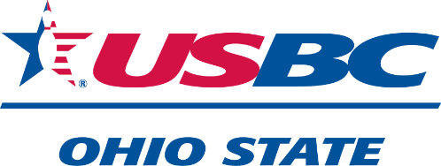

January 1, 2025

Dear Ohio Bowling Hall of Fame Member, Life Member, Member Emerita:

At the 2020 Annual Meeting of the Ohio State USBC, the delegates approved a change to the Bylaws that allows Hall of Fame members the right to attend the Annual Meeting of the Ohio State USBC, with voice and vote. The Life Members and Member Emerita also have the right to attend the Annual Meeting of the Ohio State USBC, with voice and vote.

Hall of Fame Members, Life Members, Member Emerita who wish to vote at the Annual Meeting of the Ohio State USBC will be required to submit a credential form and register in the same manner as local association delegates.

The 2025 Annual Meeting will be held on Saturday, May 17, 2025, at 2:00 PM at the Embassy Suites at Columbus Airport, 2886 Airport Dr, Columbus OH 43219. Deadline for submitting your credentials is **March 19, 2025.**

A credential form is enclosed for your convenience, and we look forward to welcoming you to our 2025 Ohio State USBC Annual Meeting.

Sincerely,

Ohio State USBC Board of Directors

Enclosure: